Thanks for checking out my Digital Breakout room. This Breakout is a role playing challenge where students are trying to a Cold War spy and trying to get out of the Soviet Union before they are found. They have to solve the clues to find their way out. It takes most students 30-60 minutes to solve it. Not all my students solve it but all think it is fun (although some get pretty frustrated in the process). Use this puzzle to introduce world geography examples of HEI in Europe and Asia. It introduces the Trans-Siberian Railway, Aral Sea, Chernobyl and Polders in Amsterdam. There is a worksheet included. Here is the website for the DIGITAL BREAKOUT and a summary of the clues and answers. ENJOY!
https://sites.google.com/forneyisd.net/sovietspyhunter/home

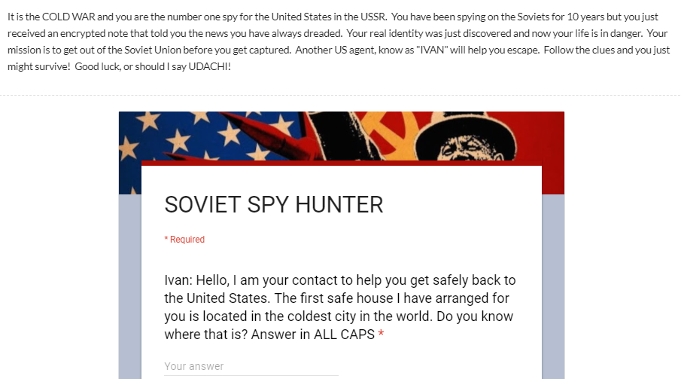
This is the first slide. It shows you the intro and then the first clue. The clue is a simple Google Search, nothing complicated here. Answers are case sensitive. The answer is YAKUTSK (a city in Siberia)

This is your second clue:
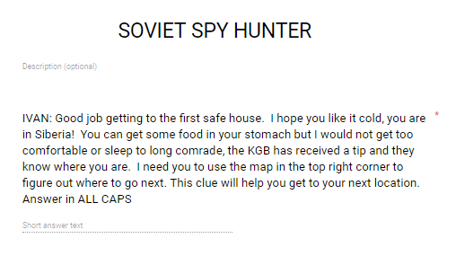
And the map:
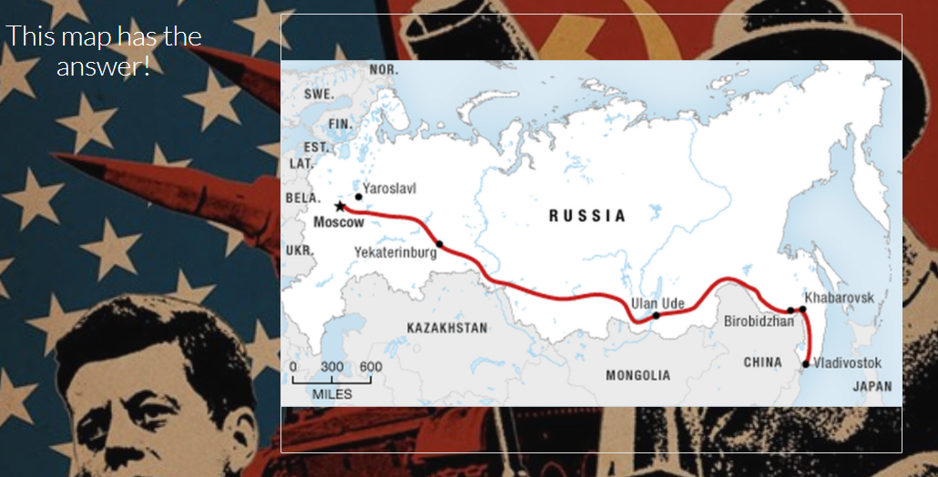
The map DOES have the answer, it is hyperlinked. When you click on the map it will take you here:
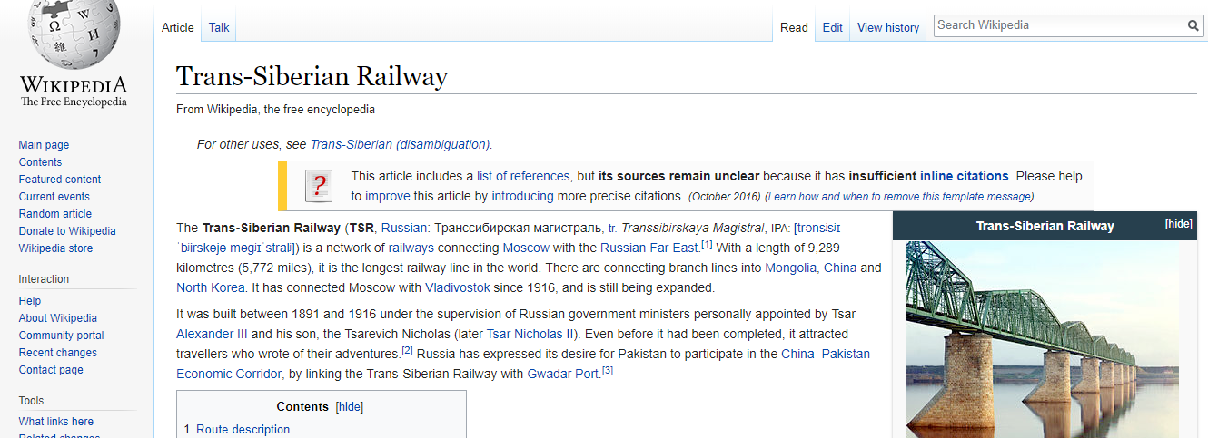
The answer for the second clue is: TRANS-SIBERIAN RAILWAY
Once you enter the answer it will take you to the third clue which is:
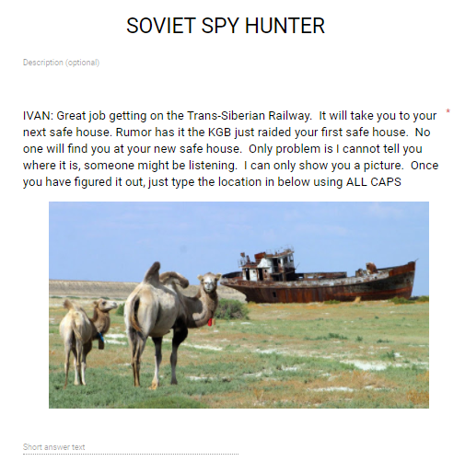
Nothing is hyperlinked, it is a google search for what you see. Eventually students will discover the answer is : ARAL SEA
That will take them to clue four:
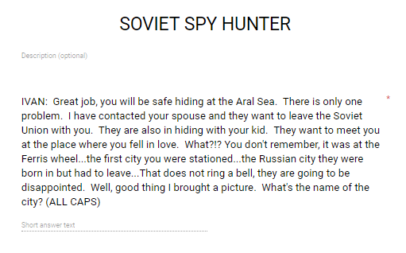
Clue four is accompanied by a picture. The picture is in the top right hand corner of the home page under the LOVE tab. The picture you see when you click on that tab is:
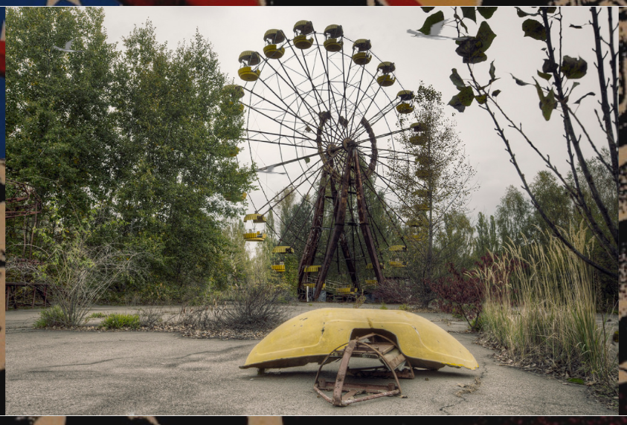
There are three birds flying around on this picture. The bird in the top left corner is hyperlinked to this website:
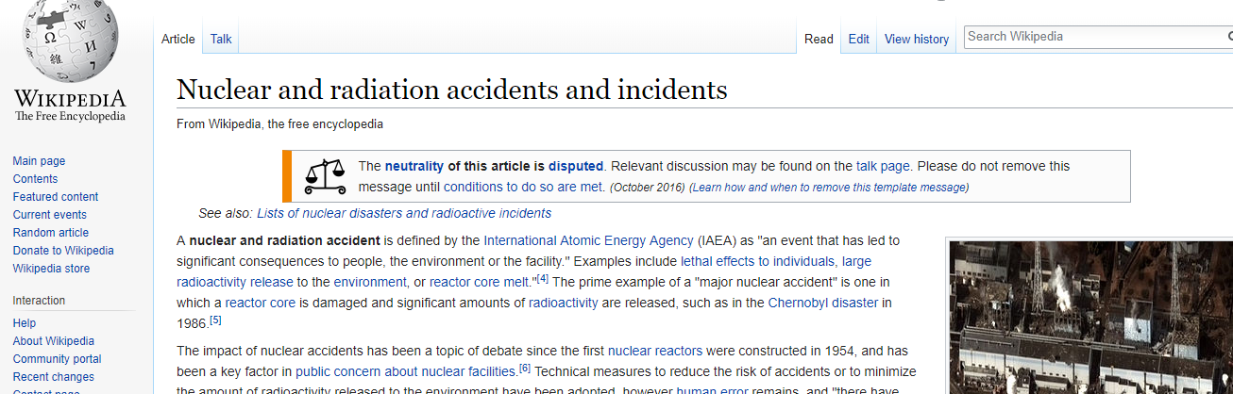
If you scroll down on this website you will see a list of nuclear accidents, two are in Russia:
The answer is the second location. The picture is located in CHERNOBYL
Here is clue Five:
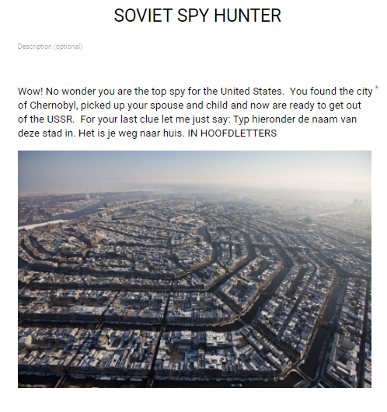
The text at the end of the clue needs to be translated. Once it is translated it says: Type the name of this city below. It is your way home. IN CAPITAL LETTERS. The key is understanding that the original language is Dutch. If you search cities that speak Dutch, you will find out the answer. The answer is : AMSTERDAM
Once they enter the answer it will take them here:
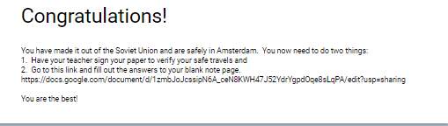
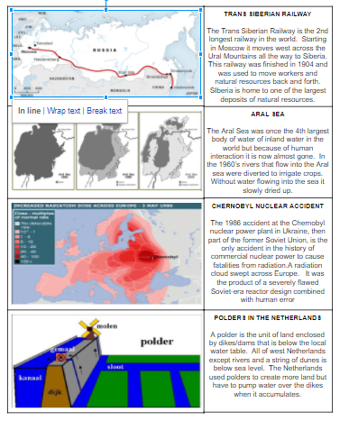The link will take them to a key, where they can copy the answer for the worksheet attached.
I have my students copy the maps/diagrams and the summaries. Enjoy!
Name
