The Pear Deck Add-on
In the past you would have to go to Pear Deck's website and import your existing slideshow, and then add the interactive elements. Now with the add-on, you can build everything right inside of Google Slides.
To install the Pear Deck add-on do the following:
- Open a Google slideshow as normal.
- Click the "Add-ons" menu at the top.
- Choose "Get add-ons" from the drop-down menu.
- This will open the "Add-ons" window where you can browse through the available add-ons.

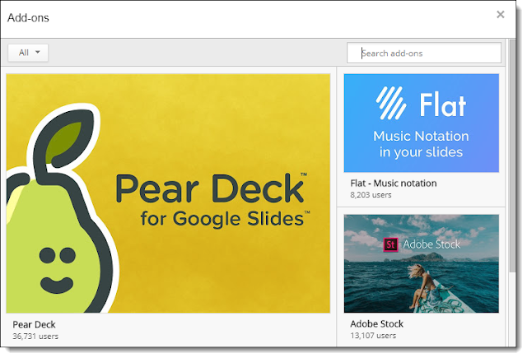
- When you find "Pear Deck" click the "+FREE" button.
- You will now need to choose the Google account you are using, and then agree to the permissions by clicking "Allow".
- The Pear Deck add-on will now be installed and available in your "Add-ons" menu from now on.
Using the Pear Deck Add-on
To use the Pear Deck add-on to make your slideshow interactive, you will want to start by building your presentation in Google Slides as normal, or by using an already existing presentation. After you have the slideshow ready like normal, you can go back through and add in the interactive Pear Deck elements.
When adding the interactive Pear Deck elements, you have two main choices:
- Add a premade interactive Pear Deck slide to your slideshow
- Add Pear Deck functionality to an existing slide
We will look at both options below.
Option 1 - Add a Premade Pear Deck Slide
With this first option, the Pear Deck add-on provides four premade slides that you can add to your presentation. These will be inserted as new slides, rather than changing the slides you already have. To use this option do the following.
- Go to the spot in your slideshow where you want the new Pear Deck slide added.
- Click the "Add-ons" menu.
- Choose "Pear Deck".
- Choose one of the following options
  - Add Warm-up Slide
  - Add Reflection Slide
  - Add Temperature Check Slide
  - Add Exit Ticket Slide ( see next page)

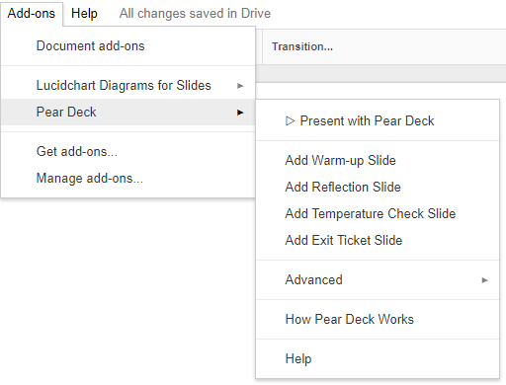

Note: The "Draggable" and "Drawing" options are not available through this option in the free version, but instead are premium paid features.
Here's how each of the non-premium options work:
1) Text
If you choose the "Text" option, when the presentation runs students will be able to type in their responses. For an example, I asked students to give an example of perpendicular lines in the real world.
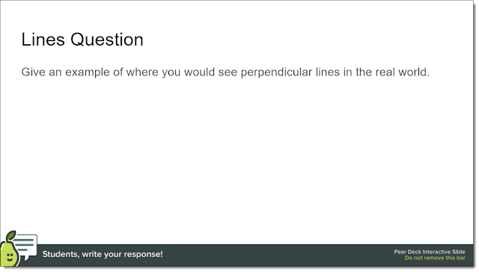

2) Number
If you choose the "Number" option, when the presentation runs students will be able to type in a numeric response to your question. For an example, I asked students to give a possible measure for an acute angle.
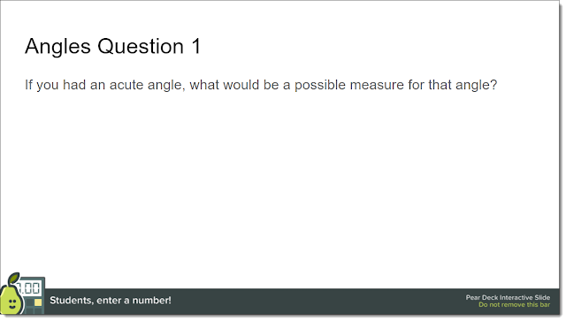
3) Multiple Choice
If you choose the "Multiple Choice" option, you will need to type in a question and possible answers. You will probably want these to match whatever you have already typed on your slide. When the presentation runs students will be able to choose an answer to your question. For an example, I asked students to choose what type of angle was being shown.
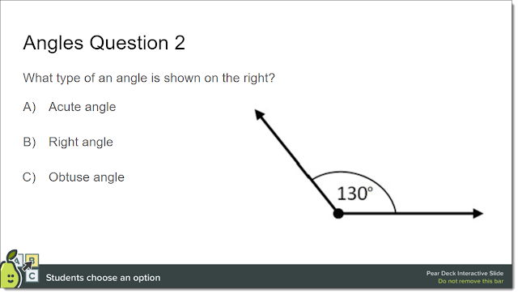

4) Web Slide
If you choose a "Web Slide" you will be asked to paste in the web address for a site. When the presentation runs the students will see that site embedded in the slideshow and will be able to browse the site.
Running the Pear Deck Slideshow
Once you are finished adding the interactive Pear Deck elements to your Google Slides presentation, you are now ready to run the slideshow as follows:
- Click the "Add-ons" menu.
- Choose "Pear Deck" from the drop-down menu.
- Choose "Present with Pear Deck"
- You may need to click "Allow" again for additional permissions.
- Your slideshow will now be imported into Pear Deck, which can take a while if you have a lot of slides or large images.
- You will now get a screen labeled "Step 1 of 3" where you need to make sure Pear Deck is showing up properly on your classroom projector.

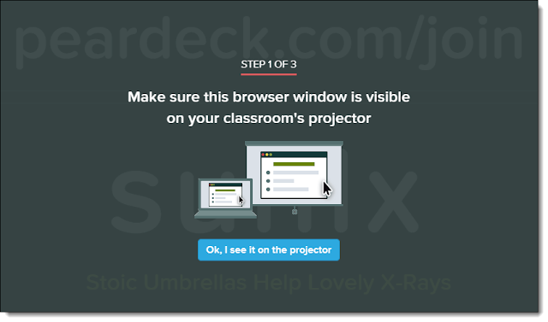

- You will now see a screen labeled "Step 2 of 3". This screen will have directions for your students to join your Pear Deck session.
- Students will need to go to peardeck.com/join and type in the code displayed.

- Once your students have joined, you are now ready to do "Step 3 of 3" which is to begin the presentation by clicking the arrow in the bottom left corner of the screen.
- As you click through the presentation, your students screens will show the current slide in sync with what you are displaying.
- When you get to the interactive slides, the students will be able to type or draw or drag as needed on their devices to respond to your questions.
- You are able to show the students responses when desired by clicking the "Project Student Responses" button in the bottom right corner of the screen. Responses can be shown individually or aggregated together to look for patterns.
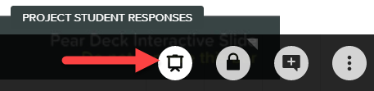

Here are some sample screens showing student responses to my questions.
When I asked the "Text" question to give an example of perpendicular lines in the real world.

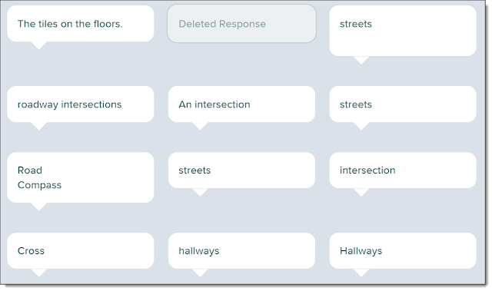
When I asked the "Number" question to give a possible measure for an acute angle.

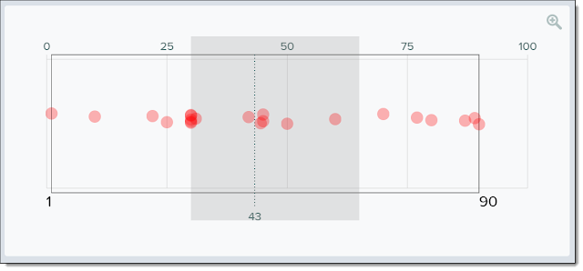

When I asked the "Multiple Choice" question to choose what type of angle was being shown
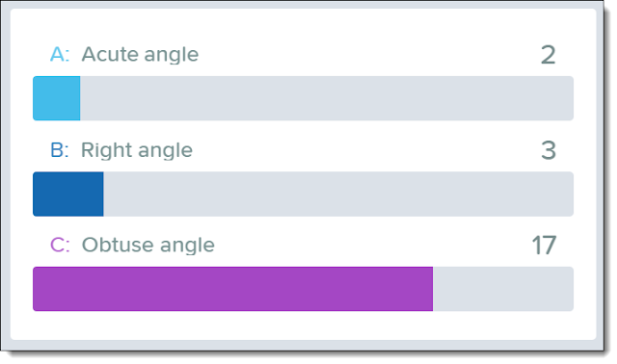

When I asked the "Drawing" question to draw an example of a quadrilateral (by editing the "Exit Ticket" slide)

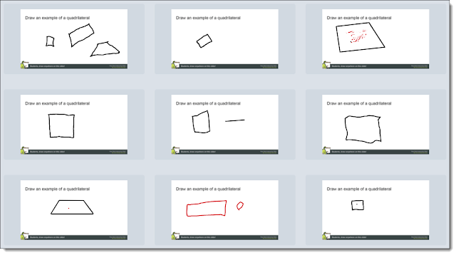

When I asked the "Draggable" question to show an example of a counting number (by editing the "Temperature Check" slide)

