Summarizing is a skill that I think we sometimes take for granted. We ask our kids to read or watch something and expect them to just be able to remember the content and apply it later during other learning activities. We can easily get caught up in the Curse of Knowledge, assuming that because we know how to summarize and organize information, everyone does too.
But our students often need scaffolding tools to help them see the difference between summarizing and retelling. For many of our students, they are one and the same. Word for word is summarizing and they end up writing way too much.

Or they don’t write enough. Or fail to capture the most important ideas.
A summary is higher order thinking and one of the best things we can do is model for our kids what it can look like. Somebody Wanted But So is a great scaffolding tool that we can use as a model and then hand over to them for individual use.

The original version of SWBS is often used with fiction but it works just as well with nonfiction, primary sources, and textbooks. The process is pretty simple:
- After students read about a historical event, lead a whole group discussion about who they think is the main person causing the events. This could be a person or a group. That person or group becomes the Somebody.
- Then ask what that person wanted. What’s the goal or motivation? That becomes the Wanted.
- Ask students what happened to keep the Somebody from achieving the Want – what’s the barrier or conflict? Write that in the But column.
- Discuss the resolution or outcome of the situation and write that in the So column.

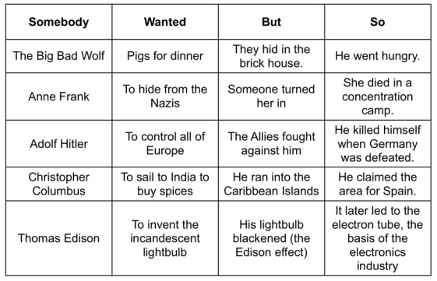
The strategy is great for:
- seeing main ideas as well as specific details
- making inferences
- identifying cause and effect
- making sense of multiple points of view
- connecting differences and motivations of different people and characters
As your students get better at the process, they will be able to work in small groups, pairs, or individuals. The basic version of SWBS works really well at the elementary level. Especially if you have kids create a foldable out of it.

As your students get better at the process, they will be able to work in small groups, pairs, or individuals. The basic version of SWBS works really well at the elementary level. Especially if you have kids create a foldable out of it.

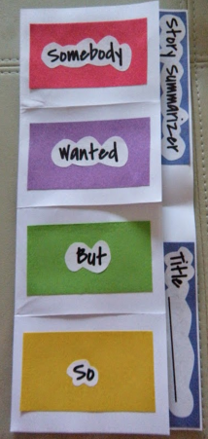

But you can ramp up expectations for middle or even high school kids by adding a T for Then and a Summary area. The Then column encourages kids to take the cause / effect idea even further by asking them to predict what might happen or to document further effects of the So column. (Make it even more complex by adding a second B column titled Because after the Wanted.)

The Summary section can be included to support narrative or argumentative writing skills and could also be used to respond to a specific writing prompt that you provide.
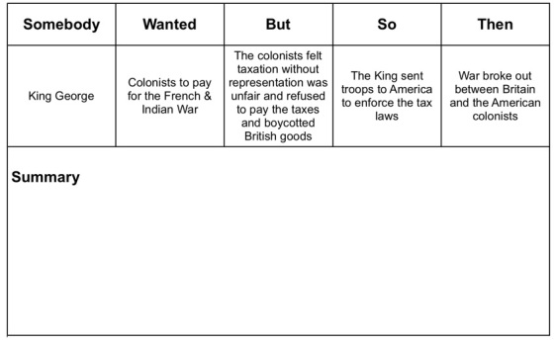

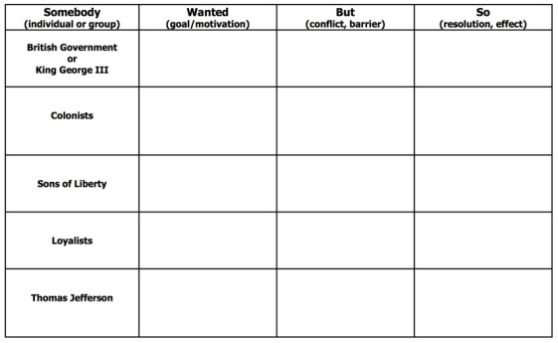
You can also add extra rows to the chart, adding additional people or groups. You could then put your own content into that column, forcing students to see different perspectives. The summary portion could then ask students to make connections between the different groups.

This could easily be done using Google Docs and Google Classroom to provide simple paperless access and sharing. Using Google Docs or other word processing tools would allow your kids to color code their charts – highlighting pieces of text as the same colors as the elements in their SWBS charts.
Students could also record a video using a tool such as Adobe Spark video to generate a visual version of their final product.
The cool thing is SWBS strategy can be adapted so that it fits your content and kids. Make it work for you. Your kids will walk out smarter than when they walked in.

