Student Created. Quizzes

- Provides agency for the students
- Students submit questions and possible responses and correct answer to you in a Google Form.
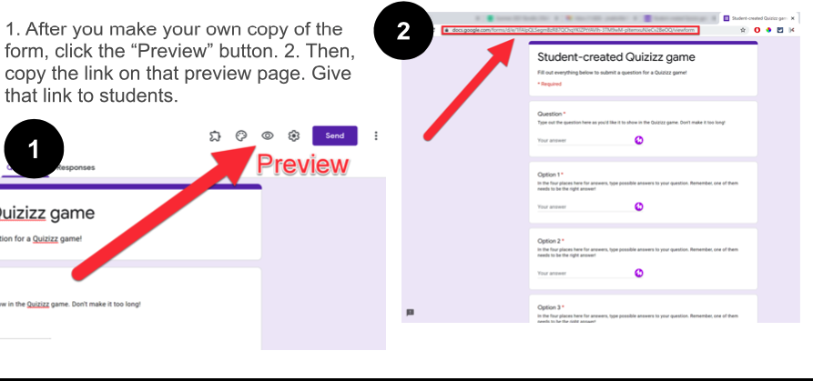
- The student creations are saved into a spreadsheet
template
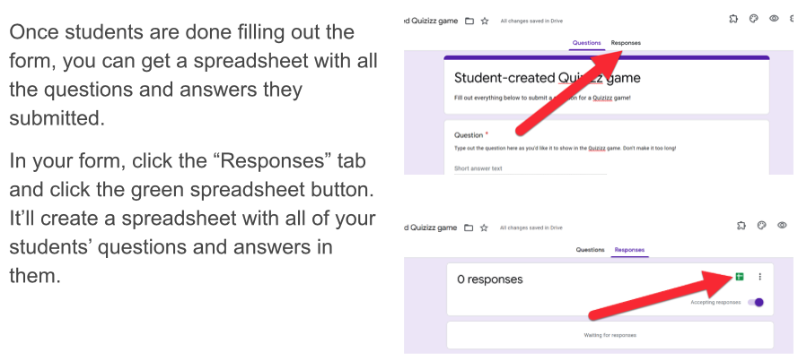
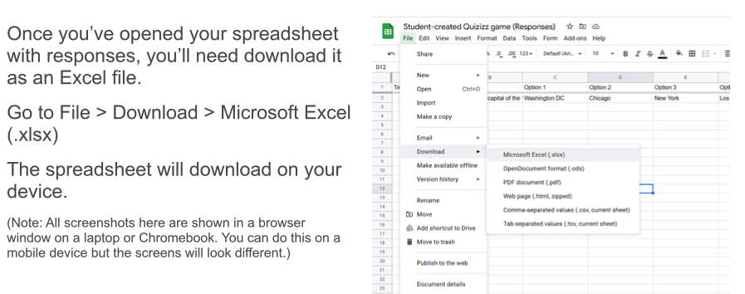
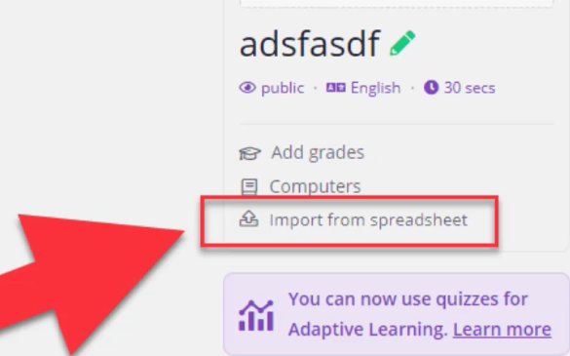
- Quizizz allows you to import spreadsheets into a Quizizz game
- Check the questions in the quiz and click publish

