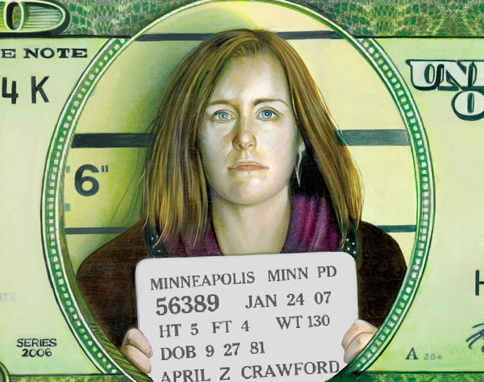
Mugged by a Mug Shot Online

By DAVID SEGAL NYTimes

Published: October 5, 2013
IN March last year, a college freshman named Maxwell Birnbaum was riding in a van filled with friends from Austin, Tex., to a spring-break rental house in Gulf Shores, Ala. As they neared their destination, the police pulled the van over, citing a faulty taillight. When an officer asked if he could search the vehicle, the driver — a fraternity brother of Mr. Birnbaum’s who quickly regretted his decision — said yes.
<Dr. Janese Trimaldi with a photo that is online from a 2011 arrest.
Mark Caramanica, a free press advocate: “Should we shut down the entire database because there are presumably bad actors out there?”
Six Ecstasy pills were found in Mr. Birnbaum’s knapsack, and he was handcuffed and placed under arrest. Mr. Birnbaum later agreed to enter a multiyear, pretrial diversion program that has involved counseling and drug tests, as well as visits to Alabama every six months to update a judge on his progress.
But once he is done, Mr. Birnbaum’s record will be clean. Which means that by the time he graduates from the University of Texas at Austin, he can start his working life without taint.
At least in the eyes of the law. In the eyes of anyone who searches for Mr. Birnbaum online, the taint could last a very long time. That’s because the mug shot from his arrest is posted on a handful of for-profit Web sites, with names like Mugshots, BustedMugshots and JustMugshots. These companies routinely show up high in Google searches; a week ago, the top four results for “Maxwell Birnbaum” were mug-shot sites.
The ostensible point of these sites is to give the public a quick way to glean the unsavory history of a neighbor, a potential date or anyone else. That sounds civic-minded, until you consider one way most of these sites make money: by charging a fee to remove the image. That fee can be anywhere from $30 to $400, or even higher. Pay up, in other words, and the picture is deleted, at least from the site that was paid.
To Mr. Birnbaum, and millions of other Americans now captured on one or more of these sites, this sounds like extortion. Mug shots are merely artifacts of an arrest, not proof of a conviction, and many people whose images are now on display were never found guilty, or the charges against them were dropped. But these pictures can cause serious reputational damage, as Mr. Birnbaum learned in his sophomore year, when he applied to be an intern for a state representative in Austin. Mr. Birnbaum heard about the job through a friend.
“The assistant to this state rep called my friend back and said, ‘We’d like to hire him, but we Google every potential employee, and the first thing that came up when we searched for Maxwell was a mug shot for a drug arrest,’ ” Mr. Birnbaum said. “I know what I did was wrong, and I understand the punishment,” he continued. “But these Web sites are punishing me, and because I don’t have the money it would take to get my photo off them all, there is nothing I can do about it.”
It was only a matter of time before the Internet started to monetize humiliation. In this case, the time was early 2011, when mug-shot Web sites started popping up to turn the most embarrassing photograph of anyone’s life into cash. The sites are perfectly legal, and they get financial oxygen the same way as other online businesses — through credit card companies and PayPal. Some states, though, are looking for ways to curb them. The governor of Oregon signed a bill this summer that gives such sites 30 days to take down the image, free of charge, of anyone who can prove that he or she was exonerated or whose record has been expunged. Georgia passed a similar law in May. Utah prohibits county sheriffs from giving out booking photographs to a site that will charge to delete them.
But as legislators draft laws, they are finding plenty of resistance, much of it from journalists who assert that public records should be just that: public. The Reporters Committee for Freedom of the Press argues that any restriction on booking photographs raises First Amendment issues and impinges on editors’ right to determine what is newsworthy. That right was recently exercised by newspapers and Web sites around the world when the public got its first look at Aaron Alexis, the Navy Yard gunman, through a booking photograph from a 2010 arrest.
The sites are designed for easy ogling. Some feature a running scroll of the famous (Lindsay Lohan), the infamous (James E. Holmes, accused in the Aurora, Colo., mass shooting) and the obscure but colorful (a man with an American flag painted on his face and bald head).
JustMugshots has a “courtesy removal service,” allowing people who have been exonerated, or never charged, or even those who can demonstrate that they have turned around their lives, to get their image taken down free. Mr. D’Antonio declined to say how many people had been granted mercy deletions.
The opposite case — a person who is guilty of a terrible crime and has the money to remove his or her face from the Web site — presents another sort of quandary. If the point of JustMugshots is to inform the public, why should the rich and convicted get a pass?
“That’s where it gets tricky,” Mr. D’Antonio said. “We review paid orders and we have refunded paid orders, if, after doing some research, it becomes clear that there is a reason to do so.”
JUSTMUGSHOTS is one of several sites named in a class-action lawsuit filed last year by Scott A. Ciolek, a lawyer in Toledo, Ohio. Mr. Ciolek argues that the sites violate Ohio’s right-of-publicity statute, which gives state residents some control over the commercial use of their name and likeness. He also says the sites violate the state’s extortion law.
“You can’t threaten to embarrass someone unless they pay you money,” he said, “even if they did exactly what you are threatening to embarrass them about.”
Dr. Janese Trimaldi, 40, a physician who recently completed her residency in Tampa, Fla.
On a terrifying evening in July 2011, she says, she locked herself in her bedroom to hide from a drunken, belligerent boyfriend. He went into the kitchen, retrieved a steak knife and jimmied open the door.
“He was more than 6 feet tall, and weighed 250 pounds,” she said by phone in Tampa. “I’m 5 feet and at the time I weighed about 100 pounds. So when he got in, he lifted me by my arms, the way you lift a child, and threw me six feet backward.”
The screams and commotion caused a neighbor to call the police. The boyfriend — whom Dr. Trimaldi did not want named for fear that he would stalk her — contended that a bleeding scratch on his chest had been inflicted by Dr. Trimaldi with the knife. (It was from one of her fingernails, she says.) She was arrested and charged with aggravated assault with a deadly weapon and battery domestic violence.
The state dropped the charges, according to a document signed by Mark A. Ober, the state attorney in Hillsborough County, Fla. A few months later, her booking photograph turned up on a Florida mug-shot Web site and with it another mug shot from a 1996 arrest on an accusation of possession of marijuana and steroids. The authorities had raided her apartment on suspicion that a different boyfriend — this one a bodybuilder — was illegally
selling the steroids. Records show that she was quickly released, and a certificate of disposition from the 13th Judicial Circuit of Florida shows that she was not prosecuted for either charge.
She paid $30 to have the images taken down, but they soon appeared on other sites, one of which wanted $400 to pull the picture.
“I’ve read accounts of people paying and not having the photos removed,” she said. “Or they pay and appear on other sites. The whole thing is a racket.”
Now studying for her medical boards and $200,000 in student loan debt, she is gearing up for a job search and worries that two photographs could wreck years of hard work to practice medicine.
“If I wasn’t a level-headed, positive person,” she wrote in an e-mail to Mr. Ciolek, the lawyer in Toledo, “I would have seriously considered ending my own life.”
People eager to vanish from mug-shot sites can try a mug-shot removal service, a mini-industry that has sprung up in the last two years and is nearly as opaque as the one it is intended to counter. “I’m not going to go into what we do,” said Tyronne Jacques, founder of RemoveSlander.com (Motto: “Bailout of the Internet for good!”). “Whatever works.”
Removal services aren’t cheap — RemoveMyMug.com charges $899 for its “multiple mug shot package” — and owners of large reputation-management companies, which work with people trying to burnish their online image, contend that they are a waste of money.

