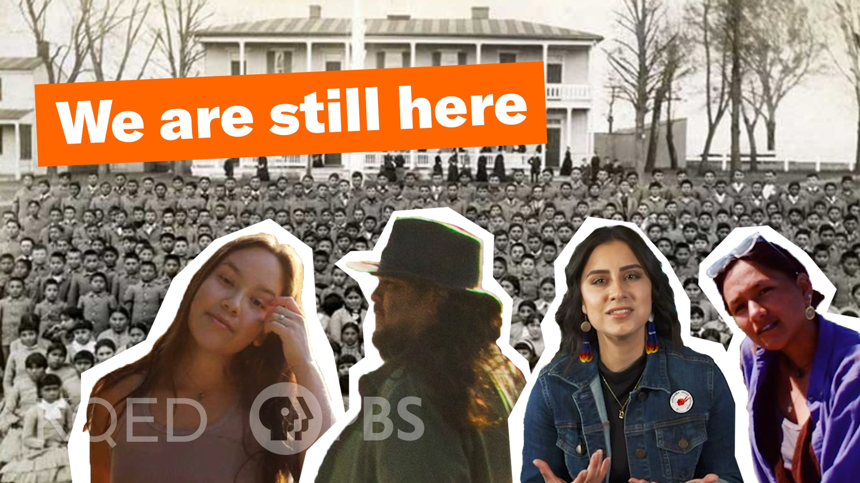

What do Indigenous youth want you to know about residential schools and current Indigenous issues?
Residential Schools are institutions run by the federal government and churches within Canada and the United States with the intention of assimilating Indigenous peoples into Western culture. Myles and Cheyenne explore the impact of Residential Schools and how Indigenous youth are healing from this history and demanding accountability. This video and lesson plan can help you facilitate a meaningful and timely conversation with your students.

Tending Nature documentary series explores how land has provided for Native peoples
For grades 6-8 STEM classes
PBS SoCal | KCET partnered with the Yurok and Karuk Tribes to show how tribal groups have actively shaped and tended the land. This series explores this relationship and possible solutions by integrating traditional knowledge from tribal groups with Western science. Includes teacher guides and student activities.

Youth Media on the Radio!
When he almost got caught up in serious trouble while trying to keep up with the cool crowd, Wilfredo Molina learned the true value of being yourself. Listen to this student piece from the Perspectives Youth Media Challenge that was selected for radio broadcast here!

