Thanks for checking out my Digital Breakout room. This Breakout is a role playing challenge where students are trying to disarm a bomb in a major city before it explodes. They have to solve the clues to find the city where the bomb is located and then disarm it. It takes most students 2-3 days (2-3 hours) to solve it. Not all my students solve it but all think it is fun (although some get pretty frustrated in the process). This is an outline that shows you what is covered from Human Geography Language content. It is best for students to have knowledge about languages before attempting it. Here is the website for the DIGITAL BREAKOUT and a summary of the clues and answers. ENJOY!

https://sites.google.com/forneyisd.net/hglanguageroom/home

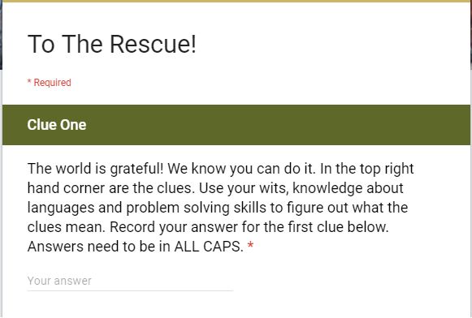

CLUE ONE:
Key to this clue is figuring out the answer to what it asks. Don't give up, you can accomplish the task!
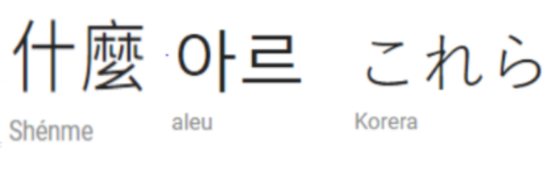
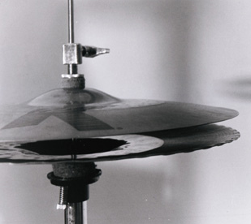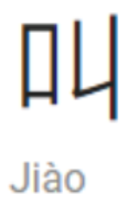

This says, “What are these symbols (cymbals) called?” It is in 3 different languages (Chinese, Korean, Japanese and Chinese) and the picture to represent the word symbol. These symbols are called LOGOGRAMS and that is the answer they need to type in the blank.
HERE IS CLUE TWO:
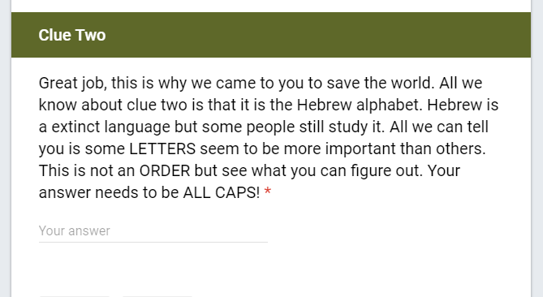
How do you find the hidden clue you cannot see? Smell? Feel? Figure it out if you want to get to clue three!
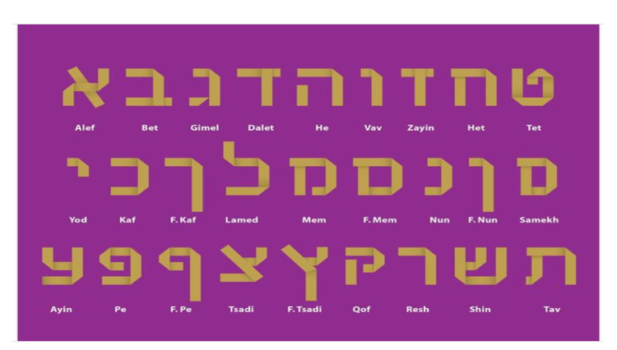
How do you find what you cannot see? You feel it. The YDNP are hyperlinked with numbers. The numbers in the correct order are the answer (That is why LETTERS and ORDER are in all caps in the clue) The answer is YDNP.

HERE IS CLUE THREE:

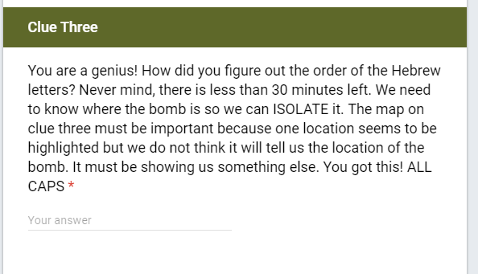
Isolate is in all caps for a reason. On the map with clue three there is a hyperlink on the France/Spain border.
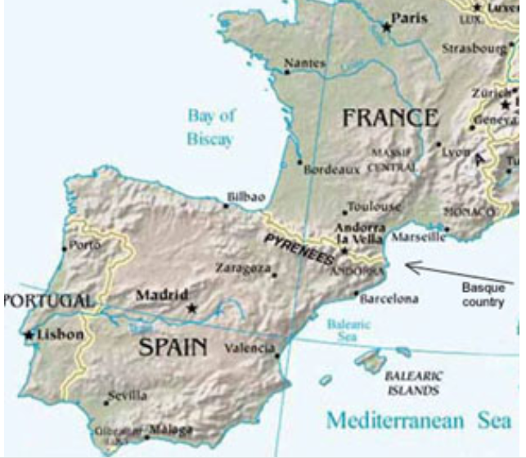
The hyperlink takes you to a page about Isolated Languages. BASQUE is an isolated language located in the Pyrenees mountains (the borders look highlighted) where the hyperlink is. It is talked about on the hyperlink. BASQUE is the answer.

HERE IS CLUE FOUR:
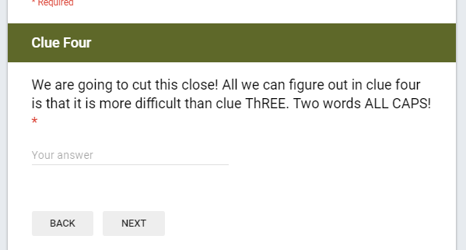
TREE is in bold for a reason. They are supposed to use their language tree knowledge to answer the question.
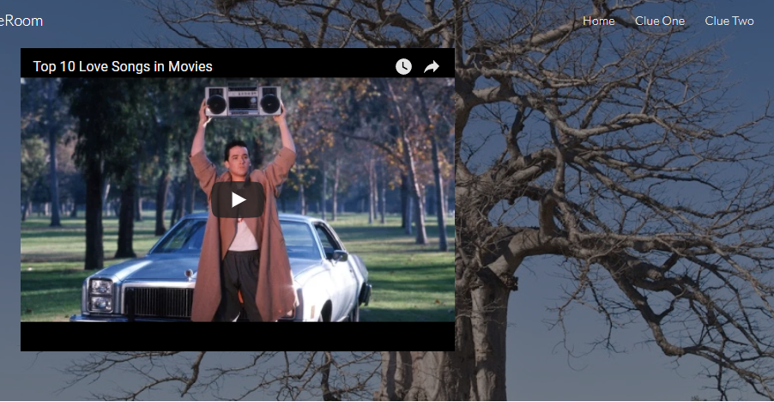
You are doing great; we are almost there! These two clues go together to eliminate the scare!

The video is about love songs and there is a tree in the background. The answer on the language tree is ROMANCE BRANCH.

CLUE FIVE:
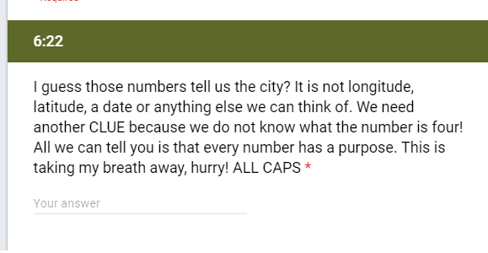
CLUE is in caps for a reason and FOUR is misspelled for a reason. If they go to the 6:22 mark on the video in clue four it will give them the answer to what city the bomb is in. Take My Breath Away is a song by….

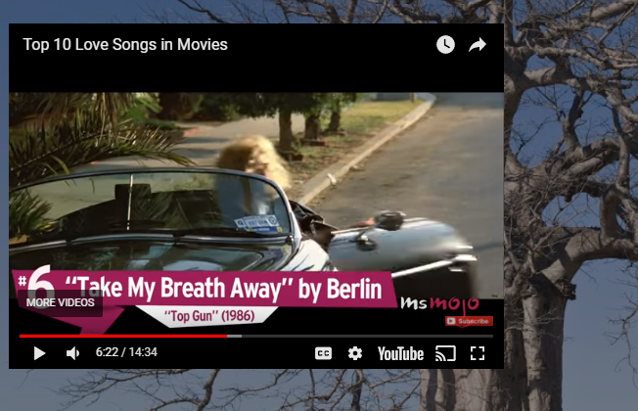
The answer is BERLIN

CLUE SIX:
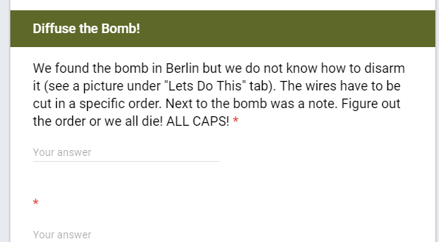
Now that they found the bomb they have to disarm it. Here is the clue.

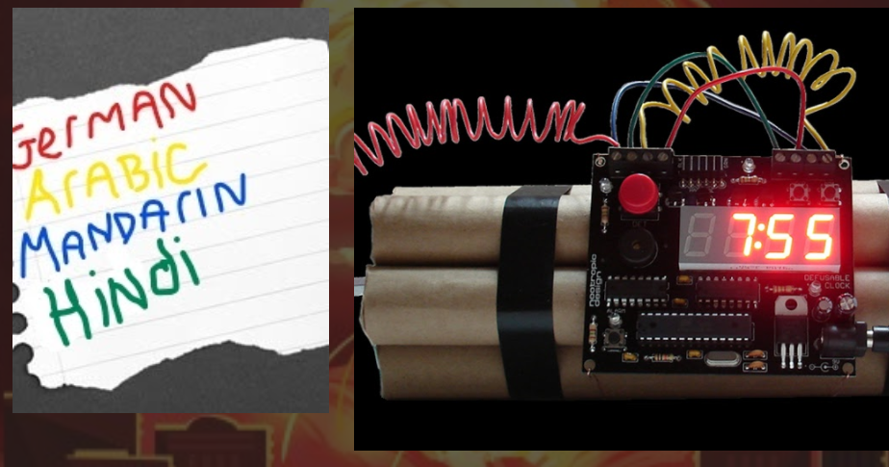

The languages have to be ranked in order of native speakers. Mandarin is the largest so they are first. The order is BLUE, YELLOW, GREEN, RED

When they disarm the bomb it takes them to this page and the world is safe!

