STEM EARLY CHAPTER BOOKS
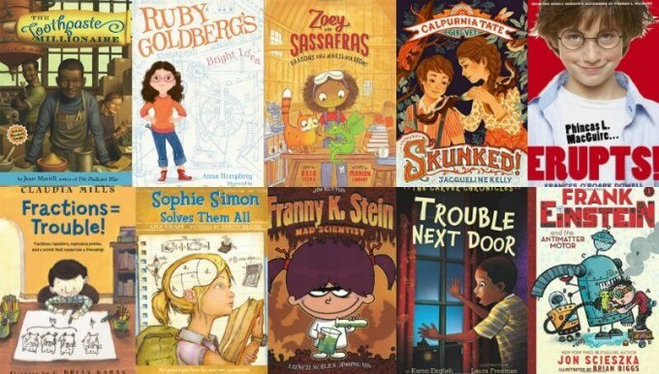
Calpurnia Tate, Girl Vet (series) by Jacqueline Kelly, illustrated by Jennifer L. Meyer. This is a spin off of the excellent middle grade novel about a budding young naturalist, Calpurnia (see below). In this series, Calpurnia and her younger brother learn to take care of the local wildlife.
Zoey and Sassafras (series) by Asia Citro, illustrated by Marion Lindsay. This new 3 book series about a can-do girl scientist who hones her skills by taking care of magical creatures will charm you. I especially love the winsome illustrations.
7 x 9 = Trouble! and Fractions = Trouble! by Claudia Mills, illustrated by G. Brian Karas. Third grader, Wilson is embarrassed that he struggles with math in school. He dreads timed tests and fears his friends will find out he has a tutor.
Trouble Next Door (Carver Chronicle series) by Karen English, illustrated by Laura Freeman. This book thoughtfully presents a moral dilemma that Calvin must work through as he learns how to make the right decisions when his science fair data doesn’t connect the dots in the way he wants.
The Toothpaste Millionaire by Jean Merrill. The practical side of math is highlighted when sixth-graders Rufus and Kate decide to invent a superior toothpaste, sell it and make their fortunes. First published 40 years ago, Jean Merrill’s book (she also wrote The Pushcart War) is still a highly entertaining celebration of the imaginative spirit.
Phineas L. MacGuire . . . Erupts!: The First Experiment (series) by Frances O’Roark Dowell, illustrated by Preston McDaniels. Phineas (aka “Mac”) is a fourth grader who goes through life looking at everything from a scientific angle. He observes, collects and applies data and when he is paired with the new kid at school for a science experiment they have to figure out how to work together. The end of the book even includes several experiments for readers to try at home.
Sophie Simon Solves Them All by Lisa Graff, illustrated by Jason Beene. I adore this “humorously brusque” heroine who is a genius in spite of her parents who aren’t quite sure why she would want to learn about calculus at the tender age of eight. Sophie, on the other hand, is still learning all about what it means to have friends.
Frank Einstein and the Antimatter Motor (series) by Jon Scieska, illustrated by Brian Biggs is a very funny series that is great for so-called “reluctant readers.” Frank is a boy genius bent on winning a science competition with his robot inventions but his rival, T. Edison, is determined to thwart him.
Franny K. Stein, Mad Scientist by Jim Benton. Franny is a young mad scientist (yes, for real!) but I love how her problems are that of a normal kid. She just wants to fit in with the other kids at school. Since she is a scientist she makes observations about what the other kids are doing (playing with dolls, dressing “cute”) and eating (squishy white bread sandwiches instead of pumpkin ravioli) and then conducts experiments to see how best she can adapt.
Ruby Goldberg’s Bright Idea by Anna Humphrey, illustrated by Vanessa Brantley Newton. Ruby sets out to win the school science fair by building the most amazing machine ever. When she finally figures out her invention, she realizes that the only person who can help her is her arch-nemesis, the winner of last year’s fair.
MORE STEM EARLY CHAPTER BOOKS:
- Science themed early chapter books
Math themed early chapter books

