STEM CHAPTER BOOKS
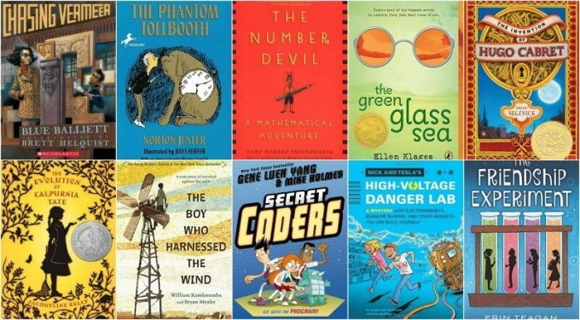
Chasing Vermeer (series) by Blue Balliet, illustrated by Brett Helquist. This book is a tour de force! When a painting is stolen, friends Petra and Calder team up to find the thief. The thief leaves a series of clues in the newspaper and challenges the community to become art detectives. If they solve the mystery, he will return the painting. Illustrator Brett Helquist incorporates clues for the reader throughout the book’s illustrations. These clues revolve around pentominoes (a math puzzle).
The Phantom Tollbooth by Norton Juster, illustrated by Jules Feiffer. Oh, you thought The Phantom Tollbooth was just about grammar and word play? Don’t forget Milo and Tock visit Digitopolis, chat up a Dodecahedron and explore curious mathematical concepts like infinity with a mathematician.
The Number Devil: A Mathematical Adventure by Hans Magnus Enzensberger, illustrated by Rotraut Susanne Berner. This is an odd sort of book, translated from the German. 12 year old Robert has trouble with math and each night in his dreams he meets the Number Devil who helps him understand various mathematical concepts, some of which are quite advanced. Illustrations are in color, which is unusual for a chapter book and math concepts are visually displayed.
The Evolution of Calpurnia Tate (series) by Jacqueline Kelly. In 1899, Calpurnia loathes the expectations set for 12 year old girls; she’d much rather read Darwin’s The Origin of Species and catch and study wildlife with her naturalist Granddaddy. I loved this tale of a girl coming of age at a time when natural science and engineering discoveries were changing the world.
Secret Coders (series) by Gene Luen Yang, illustrated by Mike Holmes. Hopper is the new kid at school and she starts things off on the wrong foot. She gets her hackles up when she gets into a tussle on her first day at the strange and creepy Stately Academy but soon Hopper and another student, Eni, team up to solve the mystery of the school. There are binary numbers to figure out, coding puzzles to solve and computer programs to unravel. If your kids can spend hours on coding websites, convince them to enjoy some off-screen time while working on the same type of problems—but with a book.
The Invention of Hugo Cabret by Brian Selznick. Hugo lives in the walls of a Paris train station when his secretive life is interrupted by the connections he makes with an unusual girl and an elderly toy vendor. A magical, marvelous, intricate, mysterious and stunning book that will inspire kids to tinker and build.
The Friendship Experiment by Erin Teagan. Madeline is starting middle school. She misses her scientist grandfather and decides to apply her research formula, what she calls her “Standard Operating Formula,” to her social life. This is a great book for kids who might not naturally be drawn to science.
Nick and Tesla’s High-Voltage Danger Lab: A Mystery with Electromagnets, Burglar Alarms, and Other Gadgets You Can Build Yourself (series) by Bob Pflugfelder, illustrated by Steve Hockensmith. 12 year old twins, Nick and Tesla live with their mad scientist uncle. They spend their days building crazy inventions, conducting science experiments and trying to solve mysteries. Instructions for the projects are included in the books along withe the necessary safety precautions.
The Green Glass Sea by Ellen Klages. In 1943, 10 year old Dewey works on her own inventive and scientific projects while her father lives and works in the secret scientific community working on the development of the atom bomb. After her father’s death and the testing of the bomb, Dewey and her friend struggle with the moral implications.
The Boy Who Harnessed the Wind (Youth Edition) by William Kamkwamba, and Bryan Mealer, illustrated by Anna Hymas. Your children will be inspired by the true story of how William Kamkwamba brought wind power to his African village.

