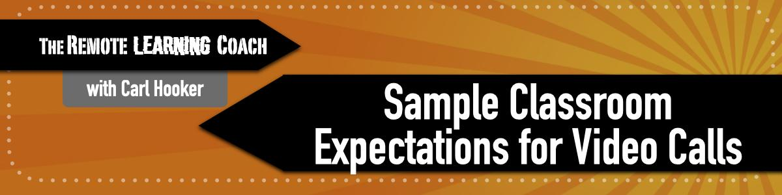

Knowing that each student at-home learning environment is different, expectations should be made fairly broad but achievable by all students if possible. Going over these expectations early and often will help ensure that video calls are more productive and less distracting. While these are general, it’s highly encouraged that you build some of the norms and expectations together as a class so students have a sense of ownership.

Once created, you should post these on your website and/or LMS to make sure all students and parents have access to it.

Some basics:

- Find a suitable place in your home to work.
- Try and log-in 5 minutes before class in case there are technical issues.
- Be respectful
- Listen to others
- Actively participate
- Dress appropriately
- Don’t eat during the call

Video call expectations
- Raise hand when you have a question or use the chat
- Mute your microphone until it’s your turn to speak.
- Turn on camera to say hello
- Use appropriate virtual backgrounds that aren’t distracting

Additional Student responsibilities

- Do not share your district or personal log-in information with others
- Minimize background noise (turn of music/tv)
- Stay focused and avoid multitasking
- Do not share the video link with others outside of your class.

