Reflecting within the Engineering Design Process
five-step Engineering Design Process developed by the Museum of Science in Boston to guide most STEM lessons and activities. In this process, students:
- Ask - What is the problem? What have others done to solve the problem? What are the constraints?
- Imagine - What are some solutions to the problem? Brainstorm. What is the best solution?
- Plan - Draw out your plan. Gather your materials.
- Create - Follow your plan and test it.
- Improve - Does it meet the goal? How can it be improved? Continue through the process as necessary to make the changes.

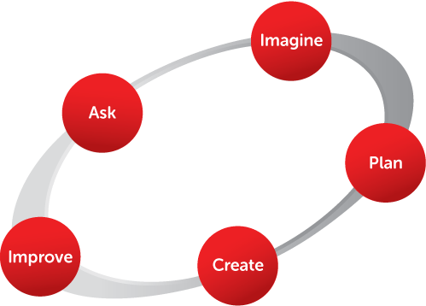

The Improve step supports the reflection process as students look back on the entire engineering experience to see what they can make better. Since students cannot truly improve their product without understanding the content, this reflective step provides an opportunity to unpack their learning.
At this point, students think objectively about their product to identify whether or not they were successful in achieving their goals. They also determine what changes could be made, and then they execute the revised process to see if the changes yielded improvement.
Daily Reflection Journals
Concurrently with the Improve stage of the Engineering Design process, students complete a daily journal that includes questions to prompt reflection and a redesign space where they can illustrate new ideas. I use Wixie and Padlet to support students’ daily reflection.

