Choice Boards

Choice is a big word in education at the moment, and for good reason. Choice is powerful in fostering student agency, independence, and engagement. Teachers are creating “choice boards” for students in the application/creation stage of learning to empower students to take their learning and apply it in a way that feels the most interesting or meaningful to them. In my experience, there is a sweet spot for providing choice. Two to three options are usually enough. When you give students a laundry list of choices, they can get overwhelmed.
overwhelmed.

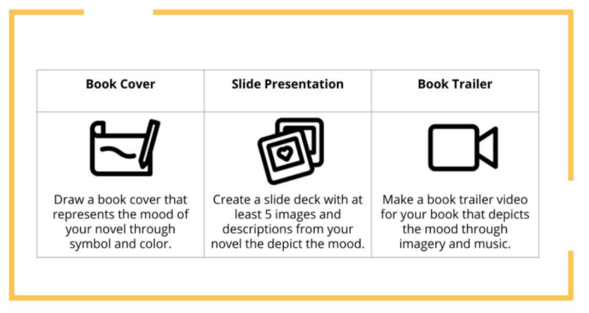
When creating choice boards, another thing to consider is student access to technology and media literacy. You might provide options that require less or more technology, so that all students feel like they have the option to choose what works best for them. This is a good practice not only in instances where students might have limited access to technology, but also for students who might not have the
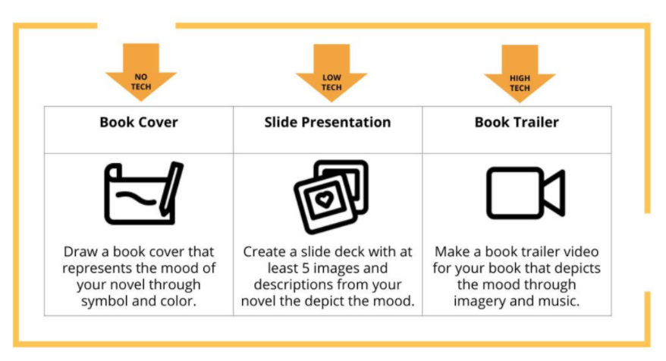
skills required to work within a certain platform or prefer not to work on their
computers all day.

