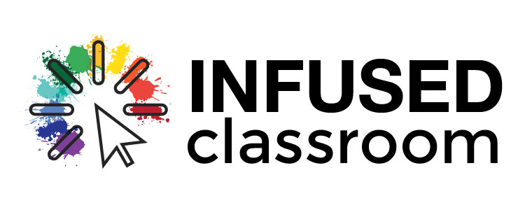

Have you heard about Chat GPT the new AI that could disrupt the modern classroom?

This new chat bot is causing quite an uproar right now among educators and non educators alike. Some people either see it as a great invention or see it as a tool that might ruin the typical English essay or math assignment. So lets dig in to see what you think...
Most of this newsletter was actually written by CHAT GPT- my added information will be in blue. Just so you know, Chat GPT wrote my subject line, and I just chose the one i thought you all might like best.
USE Chat GPT

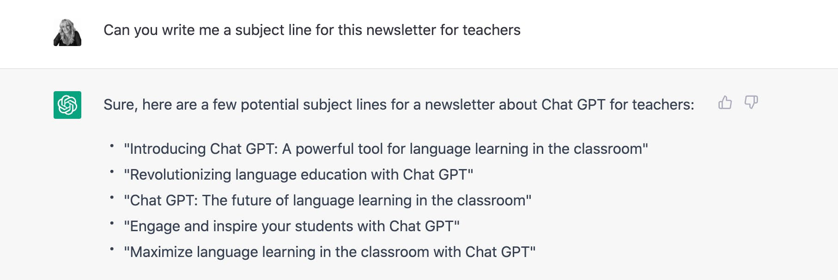

What is Chat GPT for teachers?
Chat GPT is a large language model trained by OpenAI. (AI is artificial intelligence) It is a state-of-the-art language generation system that can produce human-like text in a wide range of styles and formats. It uses cutting-edge machine learning techniques to generate text that is coherent, fluent, and relevant to a given context.
You ask it questions or queries and it responds.

Check out these three TikToks on Chat CPT to help you better understand its power.

Great overall description of what it does
How Chat GPT might it impact jobs
Potential Misinformation
New approach to looking at Chat GPT
Fun: Chat GPT writes song about Elon Musk and Drake
Atlantic Article: The End of High School English?

Example query I asked on Chat GPT...and its response
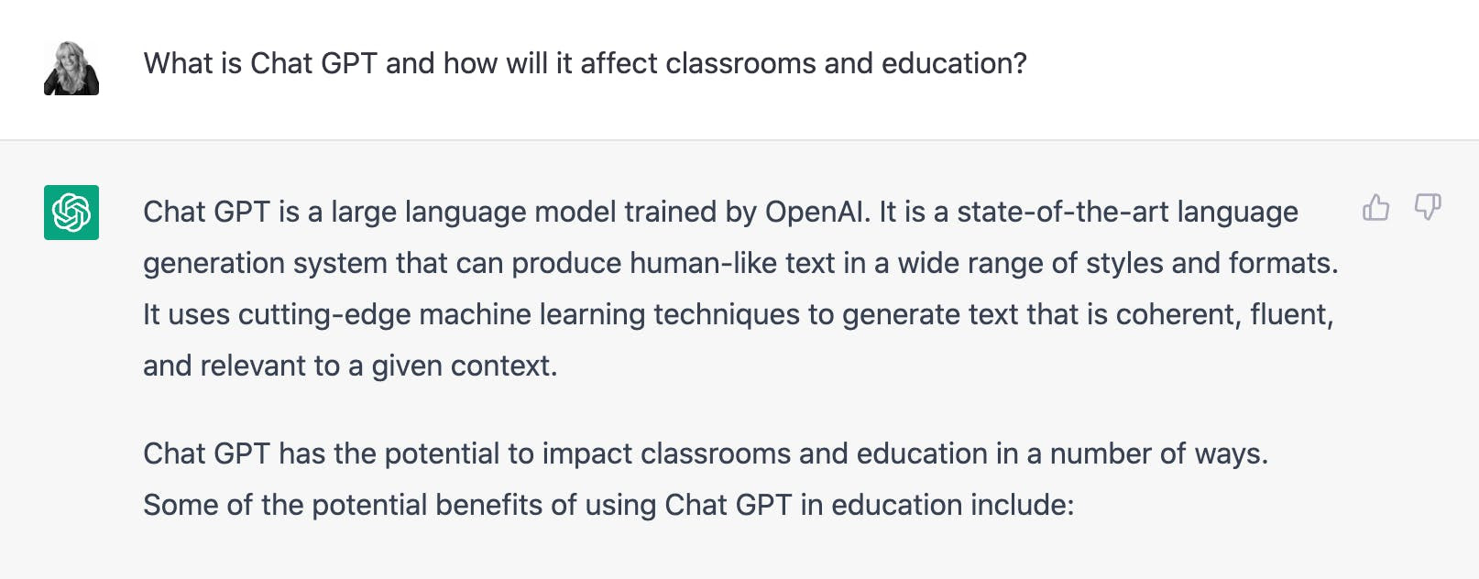

How will Chat GPT affect classrooms?

In the classroom, Chat GPT can be fine-tuned to generate text on specific topics, making it a valuable resource for lesson planning and class activities. And because it can generate text in a variety of styles and formats, it can be a useful tool for helping students to understand and produce different types of writing.
Next query by me: Can you talk about lesson ideas for chat GPT in the classroom
Sure, here are a few potential lesson ideas for using Chat GPT in the classroom:
- Conversation practice: Chat GPT can be used to help students practice their conversation skills. By engaging in a conversation with Chat GPT, students can get instant feedback on their responses and improve their ability to carry on a natural-sounding conversation.
- Writing practice: Chat GPT can be used to help students practice different types of writing. For example, it can generate persuasive essays, news articles, or even poems. This can be a valuable resource for students who are learning to write in different styles and formats.
- Vocabulary and grammar practice: Chat GPT can be fine-tuned to generate text on specific topics, making it a valuable resource for lesson planning and class activities. By engaging with Chat GPT, students can learn new vocabulary and practice their grammar skills in a fun and interactive way.
- Reading comprehension: Chat GPT can generate text on a wide range of topics, making it a useful tool for teaching reading comprehension. By having students read and respond to texts generated by Chat GPT, teachers can help students improve their ability to understand and analyze written material.
I bolded the words...
What are some of the negative impacts of AI in the classroom?

While there are many potential benefits of using AI in the classroom, there are also some potential negative impacts to consider. Some of these negative impacts include:
Dependency: If students become too reliant on AI tools, they may lose the ability to think critically and solve problems on their own. This could lead to a lack of creativity and critical thinking skills in students.
Privacy concerns: The use of AI in the classroom raises privacy concerns, as student data may be collected and used by AI systems without their knowledge or consent. This could lead to concerns about the ethical use of student data.
Inequalities: The use of AI in the classroom could exacerbate existing inequalities, as students from disadvantaged backgrounds may not have access to the same resources and technology as students from more privileged backgrounds. This could lead to further disparities in educational outcomes.
Loss of jobs: The use of AI in the classroom could potentially lead to the loss of jobs for teachers and other education professionals. This could have negative economic impacts on the education sector.
The key is not over-react to any new form of technology, but rather start an open dialogue with people around the district about how it can be used to improve education. I don't think it made my newsletter better, but I could have used the information to begin my own writing or lead to my own personal better understanding of AI and what I was writing about, but I strongly feel this newsletter still needed my voice.

