- Bookless library offers glimpse of the future. 5 Jan 2014 The Philadelphia Inquirer By Paul J. Weber ASSOCIATED PRESS
- I told our people that you need to take a look at this. This is the future. If you’re going to be building new library facilities, this is what you need to be doing.
Mary Graham, vice president of South Carolina’s Charleston Metro Chamber of Commerce
SAN ANTONIO — Texas has seen the future of the public library, and it looks a lot like an Apple Store: Rows of glossy iMacs beckon. iPads mounted on a tangerine-colored bar invite readers. And hundreds of other tablets stand ready for checkout to anyone with a borrowing card.
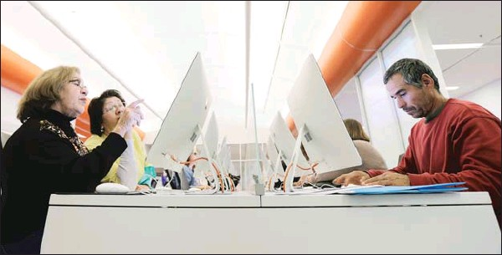 Ramirez and Sam Martinez use computers at BiblioTech, a first-of-its-kind digital public library in San Antonio. Bexar County’s BibiloTech is believed to be the nation’s only bookless public library.
Even the librarians imitate Apple’s dress code, wearing matching shirts and that standard-bearer of geek-chic, the hoodie. But this $2.3 million library might be most notable for what it does not have — actual books.
That makes Bexar County’s BibiloTech the nation’s only bookless public library, a distinction that has attracted scores of digital bookworms, plus emissaries from as f ar away as Hong Kong who want to learn about the idea and possibly take it home.
“I told our people that you need to take a look at this. This is the future,” said Mary Graham, vice president of South Carolina’s Charleston Metro Chamber of Commerce. “If you’re going to be building new library facilities, this is what you need to be doing.”
All-digital libraries have been at colleges for years. But the county, which runs no other libraries, made history when it decided to open BiblioTech. It is the first bookless public library system in the country, according to information gathered by the American Library Association.
Similar proposals in other communities have been met with doubts. In California, the city of Newport Beach floated the concept of a bookless branch in 2011 until a backlash put stacks back in the plan.
Graham toured BiblioTech in the fall and is pushing Charleston leaders for a bond measure in 2014 to fund a similar concept, right down to the same hip aesthetic reminiscent of Apple.
Except Apple Stores aren’t usually found in parts of town like this. BiblioTech is on the city’s economically depressed South Side and shares an old strip mall with a Bexar County government building. On a recent afternoon, one confused couple walked into the library looking for the justice of the peace.
San Antonio is the nation’s seventh-largest city but ranks 60th in literacy, according to census figures. Back in the early 2000s, community leaders in BiblioTech’s neighborhood of low-income apartments and thrift stores railed about not even having a nearby bookstore, said Laura Cole, BiblioTech’s project coordinator. A decade later, Cole said, most families in the area still don’t have wi-fi.
Residents are taking advantage now. The library is on pace to surpass 100,000 visitors in its first year. Finding an open iMac among the four dozen at BiblioTech is often difficult after the nearby high school lets out, and about half of the facility’s e- readers are checked out at any given time, each loaded with up to five books. One of BiblioTech’s regulars is a man teaching himself Mandarin.
Head librarian Ashley Elkholf came from a Wisconsin high school library and recalled the scourges of her old job: misshelved items lost in the stacks, pages ripped out of books and items that went unreturned by patrons who were unfazed by measly fines and lax enforcement.
But in the few months since BiblioTech opened, Elkholf has yet to lend out one of her pricey tablets and not see it again. The space is more economical than traditional libraries despite the technology: BiblioTech purchases its 10,000-title digital collection for the same price as physical copies, but the county saved millions on architecture because the building’s design didn’t need to accommodate printed books.
Across the room, Rosemary Caballeo tried shopping for health insurance on a set of computers reserved for enrollment in the Affordable Care Act. Her restless 2-year-old ran around and pawed at a row of keyboards. The little girl shrieked loudly, shattering the main room’s quiet. She was soon whisked outside by her father.
After all, it’s still a library.

