Best 3D Classroom Printers
By Shannon Mersand 4 days ago
Choosing the right 3D printer can be difficult with so many choices on the market.

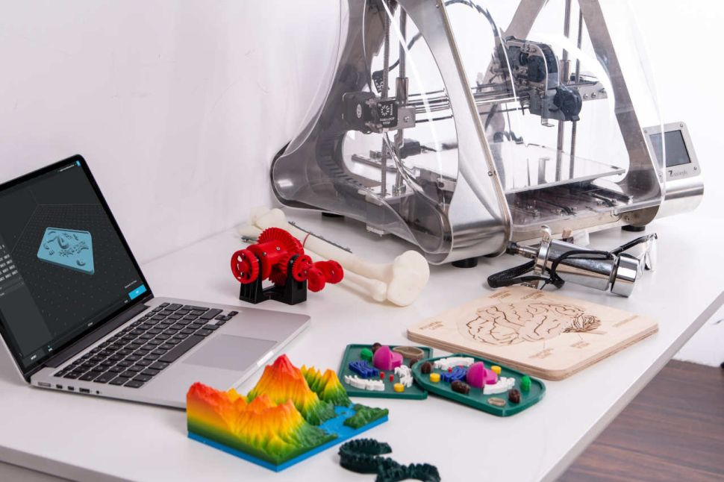

Best 3D Classroom Printers
Though originally considered by some as yet another fad, 3D printers have become increasingly prevalent in schools. 3D printers can be found in libraries, technology labs, innovation labs, and similar locations within schools. 3D printing and 3D printers, depending on how they are used, can help build students’ visual spatial, math, engineering, design, critical thinking, and problem solving skills.
Choosing the right 3D printer can be difficult with so many choices on the market. While price often plays a considerable part, the features of a 3D printer and available support should play a role as well. Here is a comparison of features of some of the top 3D printers for preK-12 schools.

Filaments to consider
Protoplant is a Vancouver, Washington based company, with a filament line dubbed Proto-pasta. Proto-pasta offers several unique filaments including composite filaments such as metal-filled, matte fiber, and carbon fiber. One of the composite filaments they offer is an electronically conductive filament that allows users to print simple circuitry for interactive projects. The conductive filament is available in two diameters 1.75mm and 2.85mm, and can be used with most PLA compatible printers with standard PLA settings. No heat bed or special extruder required! Proto-pasta also offers heat treatable PLA, which provides more durable prints once they have been heat treated, and Polycarbonate-ABS Alloy, also designed to print resilient parts.

3D Printing Curriculum
Several manufacturers, as well as other companies offer 3D printing curriculum to help educators introduce 3D printing to students. The Educators Guidebook from Makerbot offers valuable lesson plans that make incorporating 3D printing into the classroom easier. The Makerbot certification program is a training opportunity (also available to purchase separately) that helps educators earn professional development credits while learning about 3D printing and designing 3D printing curriculum, and is ISTE-certified.
The Dremel EDU bundle includes 30 standard-based lesson plans ranging from how to 3D print, to using printed items to learn additional curricular concepts. Their EDU bundle also includes a 4 Hour professional development course for teachers.
The Flashforge curriculum includes 3 lesson packs with 21 lessons, complete with presentations and 190 resources. The lesson packs include beginner, intermediate, and advanced and are aligned with the Autodesk suite.
Autodesk offers a suite of 3D modelling software, including Fusion 360, Inventor, AutoCAD, MAYA, 3DS MAX, and Tinkercad, all of which are available free to educators and students. In addition, Autodesk offers wide variety offer courses in how to use their product, as well as projects and competitions.
Tinkerine U offers multiple resources on 3D printing, including courses, stories, experiments, and challenges for students and teachers.

More 3D Printing Options
Looking for a more flexible 3D printing solution? Learn more at Tech&Learning's latest article on 3D pens. To read about how schools are using 3D printing in the classroom, check out 3D Printing in Action.

